Tiqwa Travel — Site Review
tiqwa-travel.vercel.app | Reviewed August 11, 2026

Issues found
Severity | Area | Issue | Evidence / Notes
Medium | Holiday Packages | Package cards don't show full info at a glance — flight/trip duration isn't listed on the card. | User needs to open the package to get basic details that should be visible up front.
Low | About page | Remove the About page. | Not needed
Low | Homepage / general UI | The border/container around "No Destinations Available" is too long relative to its content, and this same oversized-border issue shows up on most bordered elements across the site — nothing lines up cleanly. | See dashboard and bookings screenshots for comparison; card borders don't align consistently with the content or with each other.
Low | Booking form (Passenger Details) | Form fields on the "Complete Your Booking" page don't look aligned. | Title, First Name, Middle Name, Last Name row and the fields below it are inconsistent in spacing/alignment.

Screenshots — elongated borders
Shared screenshots showing the oversized/misaligned border issue, especially on the booking form fields.

Dashboard — card borders longer than content
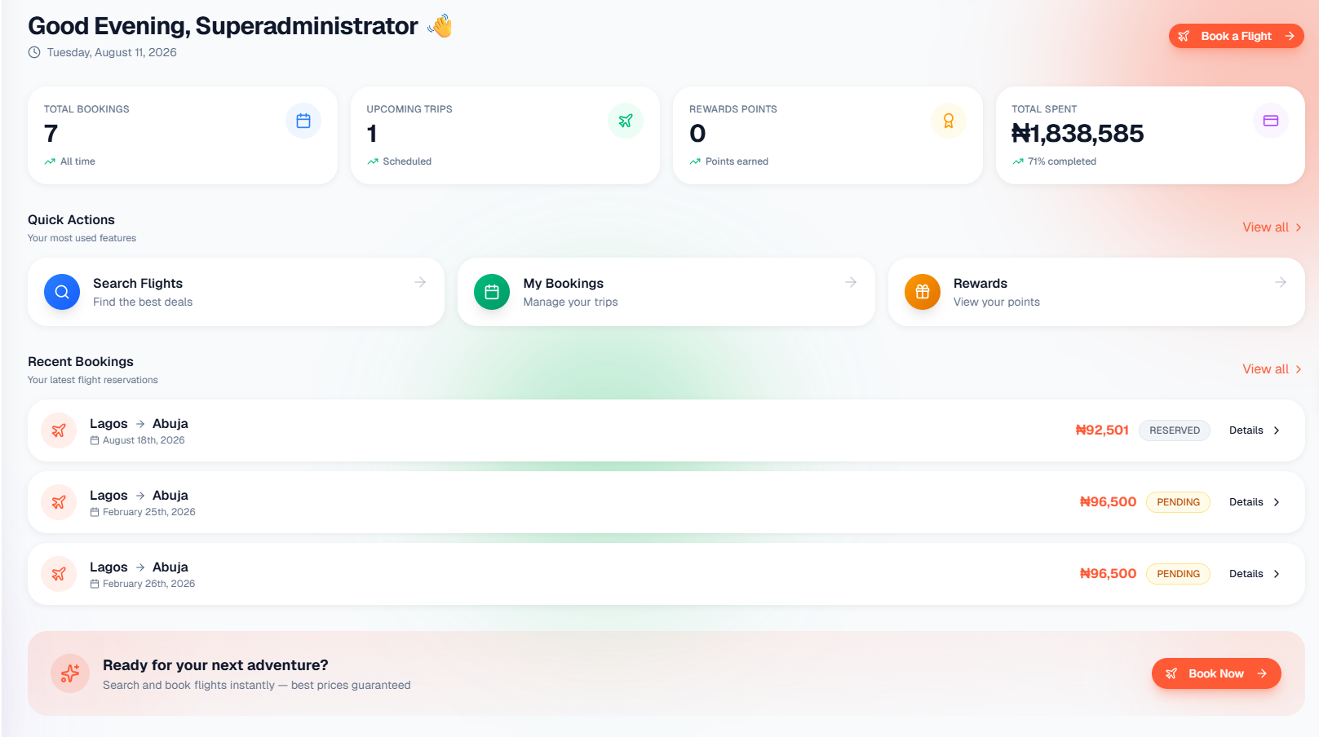
Total Bookings / Upcoming Trips / Rewards Points / Total Spent cards, and the Quick Actions / Recent Bookings rows below them, all show the same oversized border pattern.

My Bookings — card borders longer than content
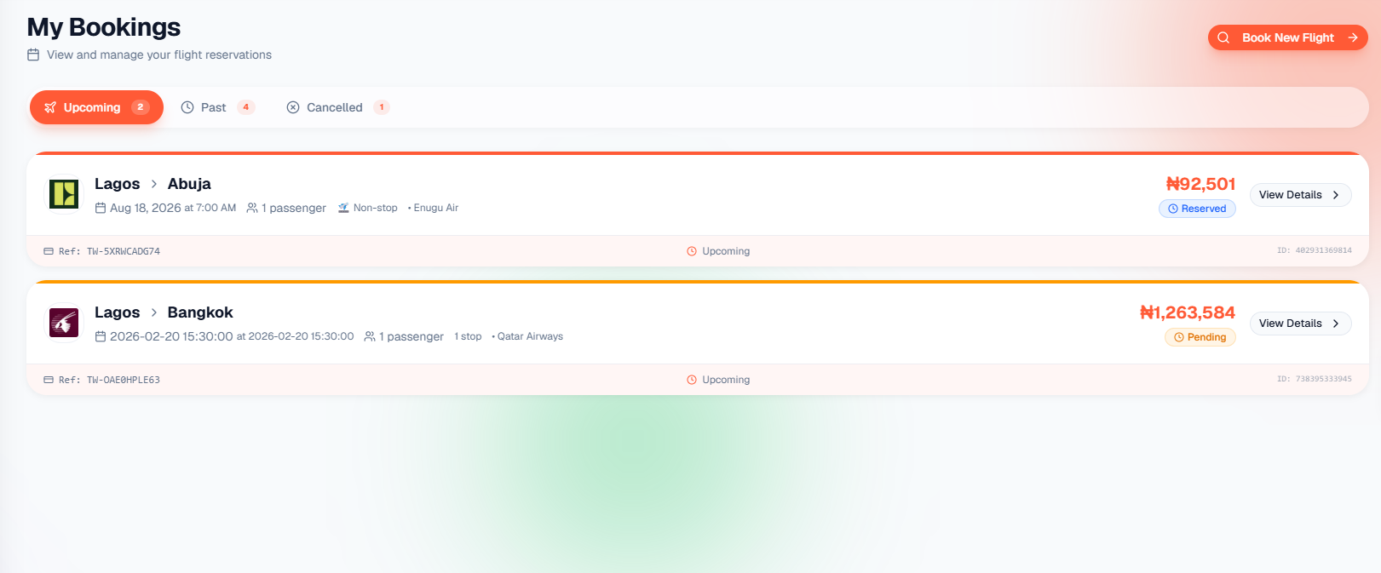
Same elongated-border issue on the upcoming booking cards.

Booking form are fields not aligned
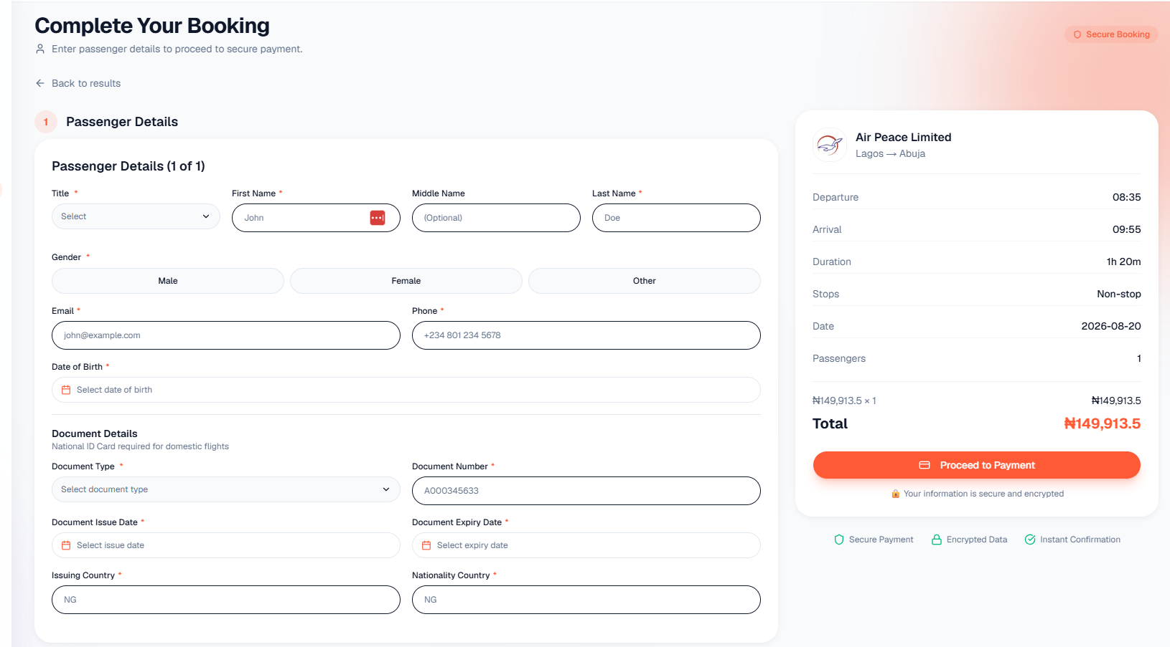
Passenger Details form: Title / First Name / Middle Name / Last Name row and the fields beneath are inconsistent in spacing and alignment; needs cleanup.

Suggested next steps
- Add trip duration to holiday package cards so key info is visible at a glance.
- Remove the About page.
- Standardize card/container border sizing sitewide, starting with the "No Destinations Available" block.
- Align form fields on the booking / Passenger Details page.

